Rubric for Evaluation of Speaker Proposal
CMC-South 2024

Shaping Our Future: Modernizing Mathematics Teaching
All proposals for the California Mathematics Council - South Section (CMC-S) 65th Annual Conference Shaping Our Future: Modernizing Mathematics Teaching program will be rated on three components: the Title & Description, the Teaching for Robust Understanding (TRU) Framework, and Equity. Each component is worth 2 points, for a total possible score of 6 points. Each proposal is reviewed by multiple committee members. We accept proposals with the highest total points in each grade span to build a balanced program.

Components

Title and Description
Your Title and Description need to be interesting and engaging. These two elements combine to communicate to the reviewers, and ultimately to those attending the conference, what the session is about, why it matters, what the experience will be like and who the session is for*. The session should address the theme Shaping Our Future: Modernizing Mathematics Teaching in a meaningful way.
*The listing of grade span is already included with your proposal and does not need to be included in the title or description.
Title and Description Score
2 points: The Title and Description are engaging and appropriate for the grade span, and the content of the session possesses relevance to the theme Shaping Our Future: Modernizing Mathematics Teaching
1 point: The content of the session possesses relevance to the theme Shaping Our Future: Modernizing Mathematics Teaching, but the Title and Description need improvement.
0 points: The Title and Description are neither engaging nor relevant.

TRU Framework
Teaching for Robust Understanding (TRU)is a framework developed by Alan Schoenfield’s of U.C. Berkley for characterizing powerful learning environments in actionable ways. It provides a straightforward and accessible language for discussing what happens (and should happen) in classrooms, in professional preparation and professional development (PD). TRU is consistent with what we know to be good practice; and it focuses classroom and administrative attention on what counts in learning (TRU Framework). Classrooms that consistently and with integrity engage in the Dimensions of the TRU Framework produce students who are powerful thinkers. We recognize that high-leverage practices and lesson designs will align to more than one of the five dimensions. Each speaker will be asked to identify with which of these five dimensions their proposal most aligns:
• Mathematical Content
• Cognitive Demand
• Equitable Access
• Agency, Authority and Identity
• Formative Assessment

While the TRU Framework was created for evaluation of classroom practice, this rubric will also apply for proposals for professional development, leadership enhancement and community involvement, etc., that help enrich the student-teacher experience described in these dimensions.

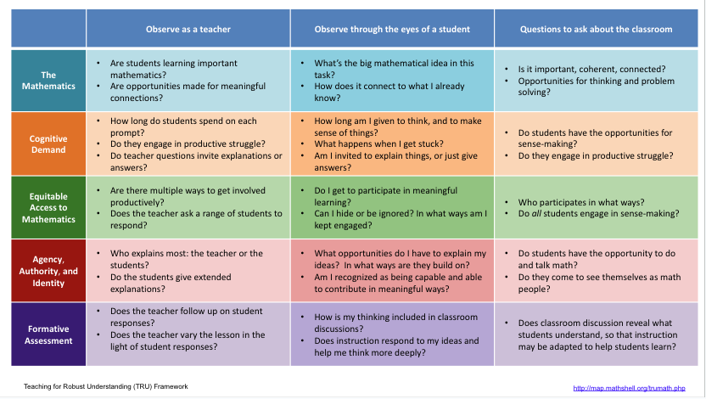

TRU Framework Score
2 points: Proposal response clearly and explicitly describes how the session will address the dimension, AND the potential is seen in the description of the session
1 point: Proposal response does not clearly describe how the session will address the dimension, but the potential is seen in the description of the session OR the proposal response clearly and explicitly describes how the session will address the dimension, but the potential is not seen in the description of the session.
0 points: Neither the proposal response nor the description addresses the dimension.

Equity

In order to maintain CMC’s commitment to evaluating all decisions through the lens of equity in mathematics education, speakers will be asked to state how their proposals will promote equity based on Rochelle Gutiérrez’s Equity Framework which focuses on access, achievement, identity, and power. (Gutiérrez, 2009)
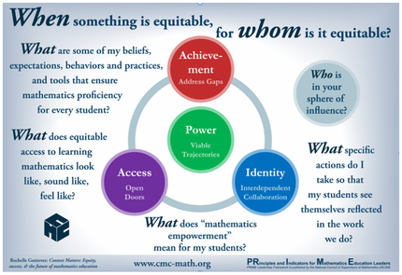

The following descriptors are provided to help craft your response:
- Access refers to the resources available to students to participate in mathematical thinking activities. Students are affected by “opportunities to learn,” therefore attending to access ensures, at the very least, they have the materials and environment they need to learn mathematics. Among the essentials are quality teachers, robust mathematics, learning for acceleration, and engaging classroom environments.
- Achievement is measured in terms of student outcomes, which include but are not limited to such as course-taking patterns, classroom participation, test scores, grades, progression through the educational pipeline and is influenced by implicit biases, culture, beliefs. Because achievement incurs economic and social consequences, i.e. low-socio economics, it is important for educators to ensure all students achieve academic excellence.
- Identity means supporting students to grow and become better mathematical thinkers “in their own eyes, not just in the eyes of others” (Gutiérrez, 2012) through their learning experiences. Instruction and curriculum encourages them to draw upon their cultural and linguistic assets for sense-making and problem-solving. Attending to identity includes attending to how students’ have and are racialized, gendered, and classed, etc.; their ancestral contributions are honored and sustained; their perspectives and practices are (in)validated throughout their learning experiences.
- Power assumes issues of social transformation at many levels: voice in the classroom (who gets to talk, who authors the mathematics), opportunities for students to use learned knowledge as a tool to analyze and respond to societal issues, alternatives ways of knowing and being, and rethinking mathematics as a more humane and joyful endeavor.
Equity Score
2 points: Proposal response clearly and explicitly describes how the session will promote equity.
1 point: Proposal response does not clearly describe how the session will promote equity, but equity promotion is seen in the description of the session OR the proposal response clearly and explicitly describes how the session will promote equity, but the potential for equity promotion is not seen in the description of the session.
0 points: Neither the proposal response nor the description addresses promotion of equity.

