Instructions:
- Analyze and discuss student solutions to the task.
  - What do you “hear” the students saying?
  - How do the students understand the math involved?
  - What is your evidence of this?
- Generate questions to further probe student thinking of the mathematics in each solution.
Student Solutions | Generated Questions
Student A

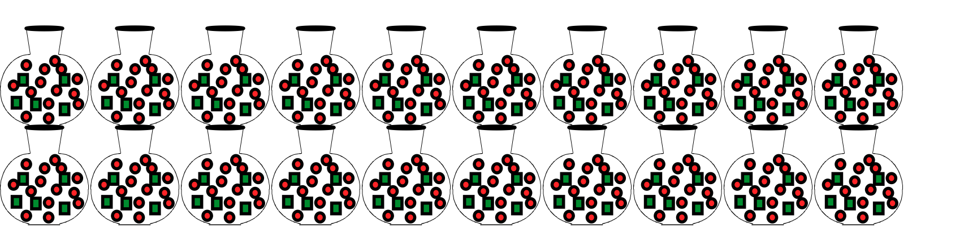

Student B
JR | JB | JR | JB
5 | 13 | 55 | 143
10 | 26 | 60 | 156
15 | 39 | 65 | 169
20 | 52 | 70 | 182
25 | 65 | 75 | 195
30 | 78 | 80 | 208
35 | 91 | 85 | 221
40 | 104 | 90 | 234
45 | 117 | 95 | 247
50 | 130 | 100 | 260

Student C
100 JR is 95 more than the 5 I started with. So I will need 95 more JB than the 13 I started with.

5 JR + 95 JR = 100 JR
13 JB + 95 JB = 108 JB

Student D
(x20)
5 JR -> 100 JR
13 JB -> 260 JB

Student E
(x10)
1 JR -> 100 JR
2.6 JB -> 260 JB

Student F